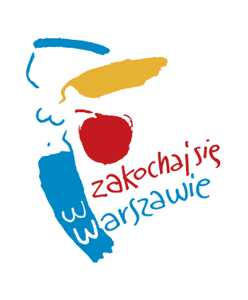

APPLICATION FORM – THE COMPETITION

- Group (team) name

....................................................................................................................

- Full name of the group (team) representative.............................................................

3. E-mail address.....................................................................................

4. I have read and accepted the Rules and Regulations of the WARSAW CHALLENGE competition to be held in 2019, available on www.warsawchallenge.com.

................................................... ...................................................................
date signature of the group (team) representative

CONSENT
TO THE PROCESSING OF PERSONAL DATA

Pursuant to Article 6 (1)(a) of Regulation (EU) 2016/679 of the European Parliament and of the Council of 27 April 2016 on the protection of natural persons with regard to the processing of personal data and on the free movement of such data, and repealing Directive 95/46/EC (General Data Protection Regulation), I am hereby granting my consent to the processing of my personal data by the Mayor of Warsaw for the purpose of attending WARSAW CHALLENGE – Open Warsaw Breakdance Championship, to be organised by the City of Warsaw on 31 August 2019, including my full name and email address.

............................... ...........................................
date legible signature

